UNIT-5
ETHICAL & LEGAL ISSUES

Ethical Issues and Legal Challenges in Digital Marketing
Ethics in business is a subject many people learn about sitting in a college lecture hall listening to a professor speak about right and wrong in the business world. The term ‘business ethics’ is a term for the procedure by which the ethical principles and moral or ethical issues that arise in a business environment are examined. Business ethics guide the norms, values, ethical practices, and unethical practices that govern the business world.

AN INTRODUCTION TO ETHICS IN DIGITAL MARKETING
More and more entrepreneurs, businesses, and larger corporate conglomerates utilize digital marketing in today’s business world. Consequently, it is essential to understand and closely monitor ethical practices well when interacting and completing business transactions on a digital platform. Digital marketing, also known as Internet marketing or online marketing, is the process by which businesses promote a product, service, or brand through various online platforms. These platforms can include social media pages, mobile apps, websites, blogs, and many others. Digital marketing allows businesses to reach a broad range of potential clients without the expense and time-consuming nature of standard business advertising.
Due to the broad-based nature and expansive capabilities of digital marketing, businesses must use caution when placing their advertisements online. Depending on the industry in which your business functions, there can be countless social, ethical, and cultural considerations that you must take into account. To make sure your digital marketing strategy appeals to your target market without offending other potential website visitors.
Traditional marketing faces similar challenges to that of digital marketing. For that matter, direct marketing is one of the most controversial methods of marketing. Some common examples of traditional or direct marketing include:
  - Television
  - Telemarketing
  - Electronic spam

LEGAL CHALLENGES IN DIGITAL MARKETING

- Privacy Law Obligations

Just like your clients, your marketing business will have its own privacy law obligations to consider. If you collect personal information on your clients’ behalf, you will need to establish a privacy policy which explains:

  - what information you are collecting; and
  - the purposes of collection.

You will also need to store data securely and only for the length of time that you need it. Your clients may also provide you with their customers’ personal data, which you may need to treat in accordance with their privacy policy. If your clients ask you to do so, make sure you review their privacy policy to ensure you know how to follow it.

Terms and Conditions

Your marketing business needs a clear set of terms and conditions for the services you provide. If you sell your marketing services to clients online, you will need a click wrap agreement agreement setting out key details.

Consumer Law and Marketing

When promoting your clients’ products and services, make sure that your advertisements will not mislead consumers. Misleading and false advertising can include representations of the:

  - nature;
  - price;
  - quality;
  - quantity; or
  - suitability of the good or service.

Another issue to be wary of is bait advertising. This can occur when you advertise a product at sale price but do not have sufficient stock to meet customer demand.
Finally, the law prevents businesses from sending spam marketing messages. This means that you must have received consent from individuals before contacting them. You also cannot send them an excessive number of messages. If you send emails on your client’s behalf, your client should communicate to their customers that it collects email addresses for use by their marketing provider.

Intellectual Property

If you use other content creators’ intellectual property (IP) (such as their music, art or photographs) to assist in your advertising, ensure that you have the appropriate permissions or licences to use them.

Competition Regulations

A competition run to advertise a company’s products or services is known as a trade promotion. If you run trade promotions for your clients, you may require a permit, depending on the states or territories in which you run the competition. This will depend on whether the trade promotion is a game of skill or game of chance, where it is being run and the total prize pool. You will also need to establish trade promotion terms and conditions, which set out:

  - who the promoter is (whether it is you or your client);
  - who can enter the competition and whether there are any age or location restrictions;
  - the timeframe for the competition;
  - requirements for entry;
  - details about the prize; and
  - how you will notify the winner.

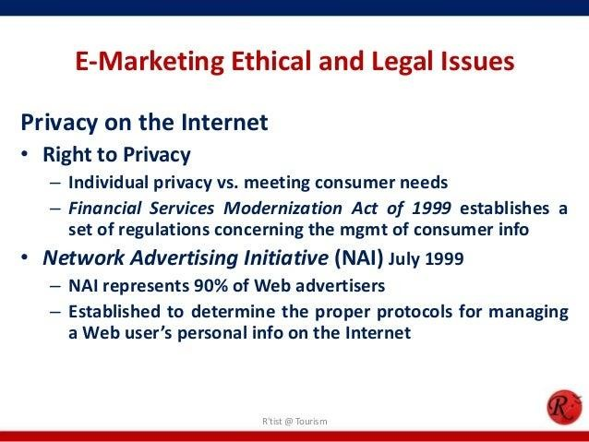

REGULATORY FRAMEWORK FOR DIGITAL MARKETING IN INDIA





